Inequality 1

- Prove the inequalty $a^{2}+b^{2}≥2ab$. If $x+y+z=c$ , show that $x^{2}+y^{2}+z^{2}≥\frac{1}{3}c^{2}.$
${\left(a-b\right)}^{2}≥0⟺a^{2}+b^{2}≥2ab$
$3\left(x^{2}+y^{2}+z^{2}\right)=x^{2}+y^{2}+z^{2}+\left(x^{2}+y^{2}\right)+\left(y^{2}+z^{2}\right)+\left(z^{2}+x^{2}\right)$
$≥x^{2}+y^{2}+z^{2}+2xy+2yz+2zx={\left(x+y+z\right)}^{2}=c^{2}$
${∴x}^{2}+y^{2}+z^{2}≥\frac{1}{3}c^{2}$
2. Find the solution set for the inequlaity: $\left|\frac{4}{x-1}\right|≥3-\frac{3}{x}$

Note that $x≠0,1$.
Case 1 If $x < 1$,
(a) If $x > 0$, that is $0 < x < 1$
$-\frac{4}{x-1}≥3\left(\frac{x-1}{x}\right)⟹\frac{4}{1-x}≥3\left(\frac{x-1}{x}\right)⟹4x≥-3{\left(1-x\right)}^{2}⟹3x^{2}-2x+3≥0$
Since $∆={\left(-2\right)}^{2}-4\left(3\right)\left(3\right)<0$, $3x^{2}-2x+3≥0$ is always true.
$0 < x< 1$ is a solution.
(b) If $x< 0$,
$-\frac{4}{x-1}≥3\left(\frac{x-1}{x}\right)⟹\frac{4}{1-x}≥3\left(\frac{x-1}{x}\right)⟹4x≤-3{\left(1-x\right)}^{2}⟹3x^{2}-2x+3≥0$
Since $∆={\left(-2\right)}^{2}-4\left(3\right)\left(3\right)<0$, $3x^{2}-2x+3≤0$ is always false.
There is no solution in this case.
Case 2 If $x > 1$,
$\frac{4}{x-1}≥3\left(\frac{x-1}{x}\right)⟹4x≥3{\left(x-1\right)}^{2}⟹3x^{2}-10x+3≤0⟹\left(3x-1\right)\left(x-3\right)≤0$
$⟹\frac{1}{3}≤x≤3$
Together with $x> 1$, the solution in this case is $1<x≤3$.
Combining case 1 and 2, the solution is $0 < x < 1$ and $1<x≤3$.

3. Solve $\left|5-2x\right|≤3x+10$ , $\left|5-2x\right|<3x+10$

Method 1
Since $\left|5-2x\right|≥0$, in order the given inequality to have solution,$3x+10≥0⟹ x≥-\frac{10}{3}$
If $x≥-\frac{10}{3}$, ${\left|5-2x\right|}^{2}≤{\left(3x+10\right)}^{2}⟹25-20x+4x^{2}≤9x^{2}+60x+100$
$⟹5x^{2}+80x+75≥0⟹x^{2}+16x+15≥0⟹\left(x+1\right)\left(x+15\right)≥0$
$⟹x≤-15 or x≥-1$
Since $x≥-\frac{10}{3}$, the solution is $x≥-1$.
Method 2
$\left|5-2x\right|≤3x+10$
$\left\{\begin{aligned}5-2x≥0 \\ 5-2x≤3x+10\end{aligned}\right.$ or $\left\{\begin{aligned}5-2x≤0 \\ -\left(5-2x\right)≤3x+10\end{aligned}\right.$
$\left\{\begin{aligned}x≤\frac{5}{2} \\ x≥-1\end{aligned}\right.$ or $\left\{\begin{aligned}x≥\frac{5}{2} \\ x≥-15\end{aligned}\right.$
$-1≤x≤\frac{5}{2}$ or $x≥\frac{5}{2}$
$∴x≥-1$.

4. Sketch on the same axes, the graphs of $y=\left|2x+1\right|$ and $y=1-x^{2}$.
Hence, solve the inequality $\left|2x+1\right|≥1-x^{2}$ .

Solve :
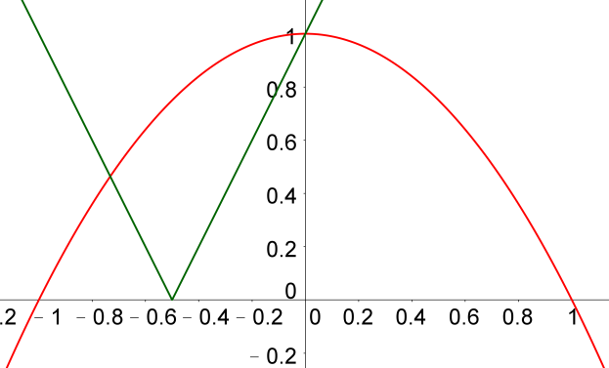
$\left\{\begin{aligned}y=-\left(2x+1\right) \\ y=1-x^{2}\end{aligned}\right.$
$\left(x=\sqrt{3}+1, y=-2 \sqrt{3}-3\right)$
$$or \left(x=1-\sqrt{3}, y=2 \sqrt{3}-3\right)$$

Solution for
$$\left|2x+1\right|≥1-x^{2}$$
is $x≤1-\sqrt{3} or x≥0$

5. Show that
$-2≤\frac{4x}{4x^{2}+2x+1}≤\frac{2}{3}$ , where x is real.

Method 1 (Quadratics)
Let $y=\frac{4x}{4x^{2}+2x+1}$
$y\left(4x^{2}+2x+1\right)=4x$
$\left(4y\right)x^{2}+\left(2y-4\right)x+y=0$
Since x is real, $∆={\left(2y-4\right)}^{2}-4\left(4y\right)y≥0$
$16-16 y-12 y^{2}≥0$
$3y^{2}+4y-4≤0$
$\left(y+2\right)\left(3y-2\right)≤0$
$-2≤y≤\frac{2}{3}$
Maximum is $\frac{3}{2}$ . Minimum is $-2$.

Method 2 (Calculus)
Let $y=\frac{4x}{4x^{2}+2x+1}$
$\frac{dy}{dx}=\frac{\left(4x^{2}+2x+1\right)\left(4\right)-4x\left(8x+2\right)}{{\left(4x^{2}+2x+1\right)}^{2}}=\frac{-4\left(4x^{2}-1\right)}{{\left(4x^{2}+2x+1\right)}^{2}}$
For critical values, $\frac{dy}{dx}=0⟹4x^{2}-1=0⟹x=±\frac{1}{2}$
For $x<-\frac{1}{2}, \frac{dy}{dx}<0$
For $-\frac{1}{2}<x<\frac{1}{2}, \frac{dy}{dx}>0$
For $x>\frac{1}{2}, \frac{dy}{dx}<0$
When $x=-\frac{1}{2}$, y is a minimum, $y=\frac{4\left(-\frac{1}{2}\right)}{4{\left(-\frac{1}{2}\right)}^{2}+2\left(-\frac{1}{2}\right)+1}=-2$
When $x=\frac{1}{2}$, y is a maximum, $y=\frac{4\left(\frac{1}{2}\right)}{4{\left(\frac{1}{2}\right)}^{2}+2\left(\frac{1}{2}\right)+1}=-2$
Therefore, $-2≤y≤\frac{2}{3}$

Yue Kwok Choy
25/9/2019

